Learners’ Survey
Academic Year 2025-2026
IGCSE Boys -College Campus
Dated: 25 & 26 September, 2025
IG-III Mars - Boys
Total Reponses: 26
Q#1: Which teachers encourage you the most to ask questions about the topics being studied and are happy to answer them? *You may select as many options as you like.
Name | Responses | Percentage
Mr. Yasir Naseer - Physics | 13 | 31%
Mr. Amir Mukhtiar - Chemistry | 12 | 29%
Ms. Zainab Afridi - English | 7 | 17%
Mr. Mirza M. Asim - Computer Science | 4 | 10%
Ms. Naureen Malik - Math | 4 | 10%
None of the above | 2 | 5%

Q#2: Which teachers report late for the class? * (You may select as many options as you like.)*
Name | Responses | Percentage
Ms. Zainab Afridi - English | 9 | 28%
None of the above | 9 | 28%
Ms. Naureen Malik - Math | 5 | 16%
Mr. Yasir Naseer - Physics | 5 | 16%
Mr. Mirza M. Asim - Computer Science | 3 | 9%
Mr. Amir Mukhtiar - Chemistry | 1 | 3%

Q#3: Which teachers conclude their classes before the allotted time? * (You may select as many options as you like.)
Name | Responses | Percentage
None of the above | 16 | 59%
Ms. Naureen Malik - Math | 6 | 22%
Mr. Mirza M. Asim - Computer Science | 2 | 7%
Mr. Yasir Naseer - Physics | 2 | 7%
Mr. Amir Mukhtiar - Chemistry | 1 | 4%
Ms. Zainab Afridi - English | 0 | 0%

Q#4: Which teachers indulge in irrelevant discussions. * (You may select as many options as you like.)
Name | Responses | Percentage
Mr. Mirza M. Asim - Computer Science | 15 | 42%
Mr. Yasir Naseer - Physics | 6 | 17%
None of the above | 6 | 17%
Mr. Amir Mukhtiar - Chemistry | 5 | 14%
Ms. Naureen Malik - Math | 3 | 8%
Ms. Zainab Afridi - English | 1 | 3%

Q#5: Which teachers use cell phones in their classes? * (You may select as many options as you like.)
Name | Responses | Percentage
None of the above | 14 | 45%
Mr. Yasir Naseer - Physics | 7 | 23%
Ms. Zainab Afridi - English | 4 | 13%
Mr. Mirza M. Asim - Computer Science | 3 | 10%
Ms. Naureen Malik - Math | 2 | 6%
Mr. Amir Mukhtiar - Chemistry | 1 | 3%

Q#6. Which teacher asks you to take paid tuition from him/her in the evening to get an A* or a good grade?
Name | Responses | Percentage
None of the above | 23 | 88%
Mr. Mirza M. Asim - Computer Science | 3 | 12%
Mr. Amir Mukhtiar - Chemistry | 0 | 0%
Ms. Naureen Malik - Math | 0 | 0%
Mr. Yasir Naseer - Physics | 0 | 0%
Ms. Zainab Afridi - English | 0 | 0%

Q#7. Which subject do you find most challenging?
Name | Responses | Percentage
Mr. Mirza M. Asim - Computer Science | 13 | 31%
Mr. Amir Mukhtiar - Chemistry | 12 | 29%
Ms. Naureen Malik - Math | 6 | 14%
Mr. Yasir Naseer - Physics | 5 | 12%
Ms. Zainab Afridi - English | 3 | 7%
None of the above | 3 | 7%

Q#8. How would you rate the teacher’s overall performance?
Name | Ranking
Mr. Yasir Naseer - Physics | 1
Ms. Zainab Afridi - English | 2
Mr. Amir Mukhtiar - Chemistry | 3
Ms. Naureen Malik - Math | 4
Mr. Mirza M. Asim - Computer Science | 5

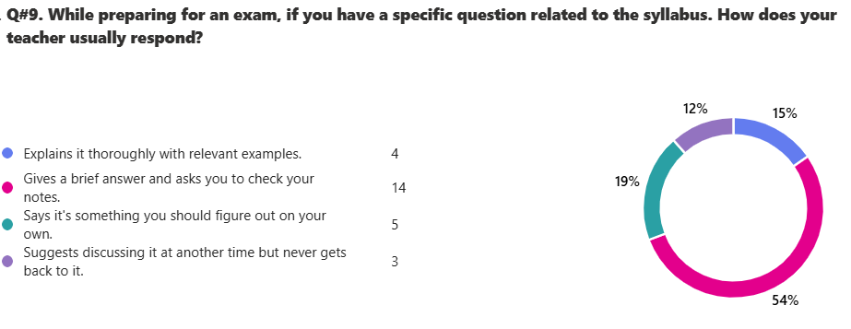

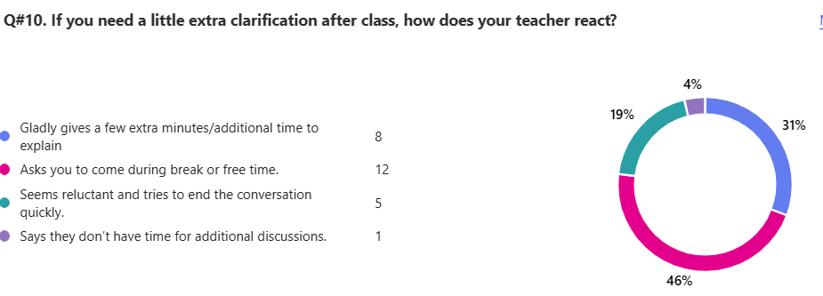

13. Any feedback that you would like to share with Board of Directors.
ID | Responses
1 | over alll ,all over teachers are good
2 | Please change the ranking system to rate each teacher individually and not as comparison to others
3 | change mam noreen as we can't understand her
4 | Change the computer sir
5 | i cant understand one word taught by Maam Noreen , her teaching is always void to me ,
6 | sir yasir explains very thoroughly with relevant examples morevoer sir amir also teaches in a friendly manner with good examples to explain the topic. at the end all teachers are as equal to another its just who i prefer, i rated above
7 | please try to follow time and improve teaching quality.
8 | Chemistry is so far one of the most challenging subject for me but the teacher we are alotted, SIR Amir, he's not much cooperative as asking him a question is enough to scare you. The look e gives easily makes us forget everything, Tho his temper is sometimes cool, but thats not a daily which we can talk about.
9 | replace english and computers teachers with maam bushra and maam shazia anjum
10 | MAAM NAUREEN STARTS CLASS TOO EARLY AND EXPLAIN THINGS VERY FAST
11 | I request the board of directors to please replace our Computer Science teacher sir Asim Mirza. Most of the time in class, the discussion is irrelevant and we dont understand one thing he is teaching. Sometimes he will start the class from programming and the other day he will start from robotics or any other chapter. Computer is a subject that i struggle the most in because of sir asim. I have been forced to take private tuition from sir Absar Moeen and finally im starting to learn something about the subject.
12 | cambridge education system is outdated and traditional, in this education system nothing innovative creative is done just memorization of formulaes, the school feels as if study is not for knowledge but for grades. finnish education system must be improvised as it is considered by many individuals as one of the best education systems in the world and if this school also give option for opting for finnish education system then this will be pakistans first school, cambridge education has immmerse stress bestowed on children with heavy books on their shoulders it is hard for them to blossom. although people like mahdin javed has uplifted aot success but one size doesnt fits all everyone has different skills different positive points, request is to offer education based on finnish education system
13 | no
14 | Overall as my first year, the teachers have been great and explain very nicely. Sometimes, sir asim can be confusing as his way of explanation isnt great. sir yasir and maam zainab explain very good. maam naureen and sir amir are good too. the class discipline is terrible and our class is always noisy and its really hard for us to focus when everyone is screaming and talking all the time. i believe that the main fault lies within the class discipline. if the class decorum is maintained better and the students who make noise are punished or thrown out of the class then the teachers can definitely teach better especially maam naureen and sir asim as in their classes, discipline is terrible.
15 | Sir Amir (Chemistry) does not do Past Paper questions/practice in class.
16 | I prefer that all the teachers should solve the past papers along with the students. For example, if a specific topic has been concluded, then they should at least dedicate 3-4 days in solving past paper questions along with the students during the classes' duration. Moreover, as we are in IG3, they should simultaneously also conduct tests of the previous topics done in IG1 and in IG2. It is also advised that the teachers should not give homework and shouldn't be conducting tests during the ASSESSMENT WEEKS, so students can dedicate their full focus to only study the respective topics of the assessments. Lastly, the teachers [of IG3] should try to revise all the topics of IG1-IG3 before the midterm examination to ensure good grades of the class.
17 | need to improve sports facilities, please install a turf of 5 aside to the beach behind our campus. the ground should atleast have grass as right now it is all dirt which destroys uniform and hygiene . lastly i firmly believe and it is my personal opinion that another photocpier should be introduced as right now there is too much workload on the current one. also IG3 students do not get the opportunity to visit chemistry lab which makes it harder to understand concepts. side by side computer lab is also not visited which makes it diffcult to learn topics like programming. i hope my concerns will be valued and i wish to see changes in the near future. than you!
18 | Sir amir mukhtiar is an excellent teacher who always helps and encourages questions from everyone. If any question he will always repeat the answer. He has an excellent knowledge for chemistry. Sir Yasir Naseer is also an excellent teacher who always explains the topic very deeply and makes sure everyone learns it well by giving examples etc. His notes are always precise and to the point. Ms Noureen is also a good teacher however she shows favoritism towards certain students. Sir Asim mirza is also an excellent teacher who has a good knowledge for computer science however he indulges in irrelevant discussions during the class. Maam zainab is a good teacher however she also shows alot of favoritism and for no reasons punishes students by sending them out of the class for example once i just sat in the classroom did nothing and she told me to leave the class.. otherwise she is a fine teacher who has a good grip in english. Moreover there is a need to improve the sports facilities as the ground behind the school is very un professional as it doesnt even have grass its just plain dust.. in addition the basketball ground is half mud and half cement which is not suitable and the hoop is broken.
19 | the information i have provided above is in no way to target any teacher, I am satisfied and grateful to have such delightful yet highly educated teachers who explain each topic in depth. Although, regarding Sir Asim, his handwritten notes on the board in most lectures are messy, so it's difficult to understand what to make of them. Moreover, in Q#4 about irrelevant discussions, i rather find them necessary, like cracking a joke, or telling a short story to get the children focused and refreshed. They all cover lectures within the class time, really well, giving us time to have a discussion on other things lifting the mood of most students. BUT they do not waste the lecture to spend some time in chit chat, our studies are their main priority.
20 | This school lacks sports facilities in comparison to other schools like beaconhouse etc. The table tennis table is not even straight and its uneven, also only one table is available because the other one is broken. The football field needs turf or grass at minimum because the dust covers the clothes and makes the uniform dirty. The basketball court is uneven and the rim is not at the correct height and also bends due to the weight of basketball. Furthermore i believe that there is need of an extra photocopier/printer as it is too busy all the time and students are unable to get workbooks on time. In studies IG3 Chemistry students do not get visits to the lab which makes understanding some topics difficult. Alongside that, the computer lab for IG3 students is not accessible which makes learning programming difficult as it requires practice on proper programming websites like Qbasic
21 | please try to maintain both studies as well as extracurriculars
22 | the teachers our very good they r skilled and master of their crafts however sometimes the lessons are delayed for 10 to 15 minuetes due to technical difficulties like hdmis functionality or other computerized issue
23 | plz change our computers teacher to mam shazia anjum plzzzz
IG-III Earth Computer Science - Boys
Total Reponses: 12
Q#1: Which teachers encourage you the most to ask questions about the topics being studied and are happy to answer them? *You may select as many options as you like.
Name | Responses | Percentage
Mr. Ali Raza Kazmi - Physics | 10 | 29%
Mr. Mohsin Saleem - Chemistry | 9 | 26%
Ms. Shougufta Adil - English | 6 | 17%
Ms. Ayesha Khalid - Math | 5 | 14%
Mr. Adnan Zafar- Computer Science | 4 | 11%
None of the above | 1 | 3%

Q#2: Which teachers report late for the class? * (You may select as many options as you like.)*
Name | Responses | Percentage
None of the above | 9 | 60%
Mr. Adnan Zafar- Computer Science | 2 | 13%
Mr. Mohsin Saleem - Chemistry | 1 | 7%
Ms. Ayesha Khalid - Math | 1 | 7%
Mr. Ali Raza Kazmi - Physics | 1 | 7%
Ms. Shougufta Adil - English | 1 | 7%

Q#3: Which teachers conclude their classes before the allotted time? * (You may select as many options as you like.)
Name | Responses | Percentage
None of the above | 9 | 64%
Mr. Adnan Zafar- Computer Science | 2 | 14%
Ms. Shougufta Adil - English | 2 | 14%
Mr. Ali Raza Kazmi - Physics | 1 | 7%
Mr. Mohsin Saleem - Chemistry | 0 | 0%
Ms. Ayesha Khalid - Math | 0 | 0%

Q#4: Which teachers indulge in irrelevant discussions. * (You may select as many options as you like.)
Name | Responses | Percentage
None of the above | 6 | 43%
Ms. Shougufta Adil - English | 3 | 21%
Mr. Mohsin Saleem - Chemistry | 2 | 14%
Mr. Adnan Zafar- Computer Science | 2 | 14%
Mr. Ali Raza Kazmi - Physics | 1 | 7%
Ms. Ayesha Khalid - Math | 0 | 0%

Q#5: Which teachers use cell phones in their classes? * (You may select as many options as you like.)
Name | Responses | Percentage
None of the above | 11 | 92%
Mr. Adnan Zafar- Computer Science | 1 | 8%
Mr. Mohsin Saleem - Chemistry | 0 | 0%
Ms. Ayesha Khalid - Math | 0 | 0%
Mr. Ali Raza Kazmi - Physics | 0 | 0%
Ms. Shougufta Adil - English | 0 | 0%

Q#6. Which teacher asks you to take paid tuition from him/her in the evening to get an A* or a good grade?
Name | Responses | Percentage
None of the above | 11 | 92%
Mr. Adnan Zafar- Computer Science | 1 | 8%
Mr. Mohsin Saleem - Chemistry | 0 | 0%
Ms. Ayesha Khalid - Math | 0 | 0%
Mr. Ali Raza Kazmi - Physics | 0 | 0%
Ms. Shougufta Adil - English | 0 | 0%

Q#7. Which subject do you find most challenging?
Name | Responses | Percentage
Mr. Mohsin Saleem - Chemistry | 7 | 44%
Ms. Ayesha Khalid - Math | 3 | 19%
Mr. Adnan Zafar- Computer Science | 2 | 13%
Mr. Ali Raza Kazmi - Physics | 2 | 13%
Ms. Shougufta Adil - English | 2 | 13%
None of the above | 0 | 0%

Q#8. How would you rate the teacher’s overall performance?
Name | Ranking
Mr. Mohsin Saleem - Chemistry | 1
Mr. Ali Raza Kazmi - Physics | 2
Mr. Adnan Zafar- Computer Science | 3
Ms. Ayesha Khalid - Math | 4
Ms. Shougufta Adil - English | 5

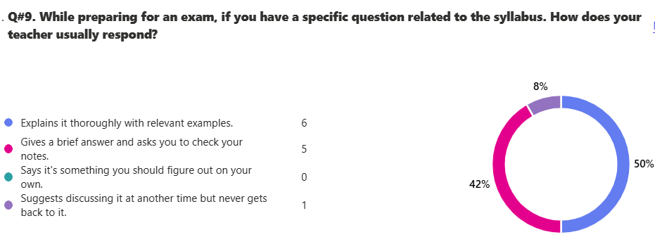

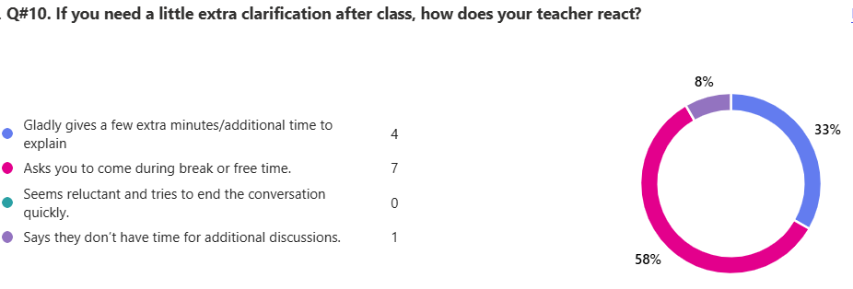

13. Any feedback that you would like to share with Board of Directors.

ID | Responses
1 | None
2 | please reduce the time of one period
3 | No
4 | ummmm inter class sports tournament woud be nice, we should also have more events especially student led events like MUN'S and whatnot.
5 | best teacher ever received
6 | increase the number of foosball tables as there is less tables and lots of people to play. thanks
7 | no

IG-III Earth Business Studies - Boys
Total Reponses: 3
Q#1: Which teachers encourage you the most to ask questions about the topics being studied and are happy to answer them? *You may select as many options as you like.
Name | Responses | Percentage
Mr. Saqib Tariq - Accounting | 2 | 50%
Mr. Kamran Yousaf - Business Studies | 1 | 25%
Ms. Shougufta Adil - English | 1 | 25%
Ms. Ayesha Khalid - Math | 0 | 0%
Mr. Tariq Mehmood - Economics | 0 | 0%
None of the above | 0 | 0%

Q#2: Which teachers report late for the class? * (You may select as many options as you like.)*
Name | Responses | Percentage
Mr. Kamran Yousaf - Business Studies | 2 | 40%
Mr. Saqib Tariq - Accounting | 1 | 20%
Ms. Ayesha Khalid - Math | 1 | 20%
None of the above | 1 | 20%
Mr. Tariq Mehmood - Economics | 0 | 0%
Ms. Shougufta Adil - English | 0 | 0%

Q#3: Which teachers conclude their classes before the allotted time? * (You may select as many options as you like.)
Name | Responses | Percentage
Mr. Kamran Yousaf - Business Studies | 2 | 50%
Ms. Ayesha Khalid - Math | 1 | 25%
None of the above | 1 | 25%
Mr. Saqib Tariq - Accounting | 0 | 0%
Mr. Tariq Mehmood - Economics | 0 | 0%
Ms. Shougufta Adil - English | 0 | 0%

Q#4: Which teachers indulge in irrelevant discussions. * (You may select as many options as you like.)
Name | Responses | Percentage
Mr. Kamran Yousaf - Business Studies | 3 | 50%
Ms. Ayesha Khalid - Math | 2 | 33%
Mr. Tariq Mehmood - Economics | 1 | 17%
Mr. Saqib Tariq - Accounting | 0 | 0%
Ms. Shougufta Adil - English | 0 | 0%
None of the above | 0 | 0%

Q#5: Which teachers use cell phones in their classes? * (You may select as many options as you like.)
Name | Responses | Percentage
Mr. Kamran Yousaf - Business Studies | 2 | 40%
Ms. Ayesha Khalid - Math | 2 | 40%
None of the above | 1 | 20%
Mr. Saqib Tariq - Accounting | 0 | 0%
Mr. Tariq Mehmood - Economics | 0 | 0%
Ms. Shougufta Adil - English | 0 | 0%

Q#6. Which teacher asks you to take paid tuition from him/her in the evening to get an A* or a good grade?
Name | Responses | Percentage
Mr. Kamran Yousaf - Business Studies | 2 | 40%
Ms. Ayesha Khalid - Math | 1 | 20%
Mr. Tariq Mehmood - Economics | 1 | 20%
None of the above | 1 | 20%
Mr. Saqib Tariq - Accounting | 0 | 0%
Ms. Shougufta Adil - English | 0 | 0%

Q#7. Which subject do you find most challenging?
Name | Responses | Percentage
Ms. Ayesha Khalid - Math | 3 | 75%
Mr. Kamran Yousaf - Business Studies | 1 | 25%
Mr. Saqib Tariq - Accounting | 0 | 0%
Mr. Tariq Mehmood - Economics | 0 | 0%
Ms. Shougufta Adil - English | 0 | 0%
None of the above | 0 | 0%

Q#8. How would you rate the teacher’s overall performance?
Name | Ranking
Mr. Saqib Tariq - Accounting | 1
Ms. Shougufta Adil - English | 2
Mr. Tariq Mehmood - Economics | 3
Mr. Kamran Yousaf - Business Studies | 4
Ms. Ayesha Khalid - Math | 5

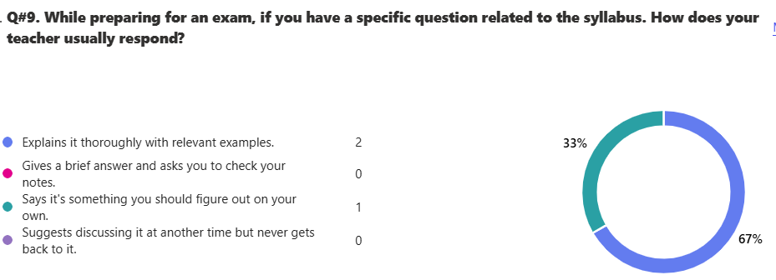

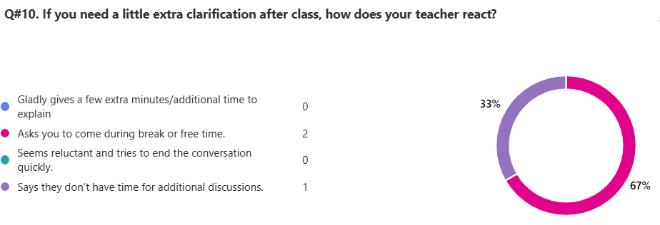
13. Any feedback that you would like to share with Board of Directors.

ID | Responses
1 | i would want that sir kamran avoid useless discussions and focus on teaching us better

IG-III Venus - Boys
Total Reponses: 24
Q#1: Which teachers encourage you the most to ask questions about the topics being studied and are happy to answer them? *You may select as many options as you like.
Name | Responses | Percentage
Mr. Yasir Naseer - Physics | 12 | 34%
Ms. Ghazal Shariq - Chemistry | 10 | 29%
Ms. Sadia Bashir- Math | 4 | 11%
None of the above | 4 | 11%
Ms. Ayesha Shoaib - English | 3 | 9%
Ms. Farheen Sajid - Biology | 2 | 6%

Q#2: Which teachers report late for the class? * (You may select as many options as you like.)*
Name | Responses | Percentage
Mr. Yasir Naseer - Physics | 12 | 43%
None of the above | 10 | 36%
Ms. Farheen Sajid - Biology | 5 | 18%
Ms. Ayesha Shoaib - English | 1 | 4%
Ms. Ghazal Shariq - Chemistry | 0 | 0%
Ms. Sadia Bashir- Math | 0 | 0%

Q#3: Which teachers conclude their classes before the allotted time? * (You may select as many options as you like.)
Name | Responses | Percentage
None of the above | 16 | 55%
Ms. Ghazal Shariq - Chemistry | 5 | 17%
Ms. Sadia Bashir- Math | 3 | 10%
Ms. Farheen Sajid - Biology | 2 | 7%
Ms. Ayesha Shoaib - English | 2 | 7%
Mr. Yasir Naseer - Physics | 1 | 3%

Q#4: Which teachers indulge in irrelevant discussions. * (You may select as many options as you like.)
Name | Responses | Percentage
None of the above | 15 | 47%
Mr. Yasir Naseer - Physics | 4 | 23%
Ms. Sadia Bashir- Math | 5 | 16%
Ms. Ghazal Shariq - Chemistry | 4 | 13%
Ms. Farheen Sajid - Biology | 2 | 6%
Ms. Ayesha Shoaib - English | 2 | 6%

Q#5: Which teachers use cell phones in their classes? * (You may select as many options as you like.)
Name | Responses | Percentage
None of the above | 16 | 55%
Mr. Yasir Naseer - Physics | 6 | 21%
Ms. Ghazal Shariq - Chemistry | 3 | 10%
Ms. Sadia Bashir- Math | 2 | 7%
Ms. Farheen Sajid - Biology | 1 | 3%
Ms. Ayesha Shoaib - English | 1 | 3%

Q#6. Which teacher asks you to take paid tuition from him/her in the evening to get an A* or a good grade?
Name | Responses | Percentage
None of the above | 21 | 88%
Ms. Ghazal Shariq - Chemistry | 1 | 4%
Ms. Sadia Bashir- Math | 1 | 4%
Ms. Ayesha Shoaib - English | 1 | 4%
Ms. Farheen Sajid - Biology | 0 | 0%
Mr. Yasir Naseer - Physics | 0 | 0%

Q#7. Which subject do you find most challenging?
Name | Responses | Percentage
Ms. Farheen Sajid - Biology | 17 | 39%
Ms. Ghazal Shariq - Chemistry | 8 | 18%
Mr. Yasir Naseer - Physics | 8 | 18%
Ms. Sadia Bashir- Math | 7 | 16%
Ms. Ayesha Shoaib - English | 4 | 9%
None of the above | 0 | 0%

Q#8. How would you rate the teacher’s overall performance?
Name | Ranking
Mr. Yasir Naseer - Physics | 1
Ms. Ghazal Shariq - Chemistry | 2
Ms. Farheen Sajid - Biology | 3
Ms. Ayesha Shoaib - English | 4
Ms. Sadia Bashir- Math | 5

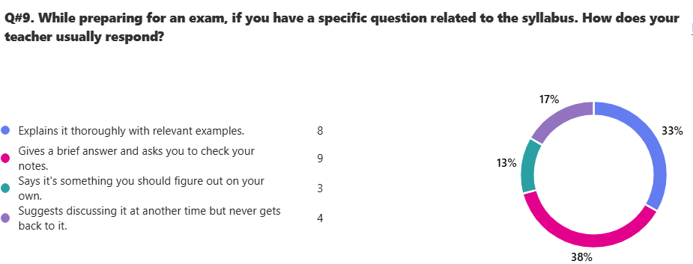

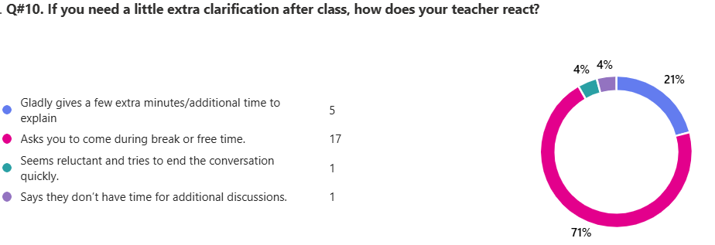

13. Any feedback that you would like to share with Board of Directors.

ID | Responses
1 | no
2 | nah our teachers r really good
3 | AOA i am not understanding anything in biology do something about it like changing the teacher
4 | Class has disciplinary issues which affects the general environment of room, and in my opinoin affects the ability to teach and learn.
5 | more open ended questions. my opinion doesnt really relate with the avaiable options
6 | question 12 was only applied to physics and chemistry
7 | i believe the teachers are just okay, nothing too perfect about any of them, plus many of them are quite annoying like most like maam ghazal and maam farheen are always targeting me for no reason at all like i didnt even do anything and even if im not doing anything they are weird so yes i do not like any of the teachers and in my opinion they shouldnt even teach at this point because the classes are just hilarious
8 | the teachers are verry arrogant and never seems to listen to students what they want. if we say something they are reluctant and says we know more than you.
9 | Aoa, i am unable to understand hardly anything during biology as we are unable to understand her properly and find it difficult to keep up with her class. All she does is make us write down notes during maximum time of her class and explains those notes in a bland and uninteresting way. I would like to say that last year during IG 2 we got a way better teacher which used to give proper and good notes and used to explain them properly and used to get our attention and would intrigue us and if a student wouldnt pay attention she would ensure that the student would still understand the lecture and force them to do so, that teacher was Mam Anila Rafaqat. We had a way better teacher in IG 2 where scieneces were not that much focused upon but now that we are in Ig 3 which is a way more important year for us as we will be appearing for sciences, we got a worse and less interesting teacher during the most important year. I strongly ask of the Board of the Directors that Mam Farheen Sajid be changed as we are not able to understand her way of teaching and neither does most of the class understand
10 | In my opinion, Maam Ayesha Shoaib needs to be better explaining a Topic and should keep a faster Pace in teaching as she takes too long on a topic compared to other classes, Maam Farheen is difficult to understand as shes too fast and not great at building concepts which is a problem for the entirety of the class, we would prefer Maam Anila as our biology teacher as shes great at building concepts and an overall image in our minds (our bio teacher from last year). -Thank You for hearing my say in this matter.
11 | AOA, I understand hardly anything in biology class as we are unable and find it difficult to understand her properly. She mostly makes us write notes and tries to finish the topic quickly by just giving us a bland which makes it nearly impossible to understand and in most of the time we try to finish our notes instead of listening to her. I would also like to say that last year we got a very good teacher whose main focus was to make us understand properly and gave us good notes which made it easier to understand and also provided us with notes sol that we could memorize them but this year all we do is try to finish our notes instead of understanding them.
12 | mam ghazal takes our break.mam farheen doese not know how to teach.She comes in class quietly and starts writting alot of words witout explaining than expects us to write everything
13 | mam Ghazal takes our breaks. I want her to not do this, and you should take this in recommendation. Thank you. I also want you to make a bigger ground because there is difficulty in playing sports. Mam Ghazal does not clarify her topics completely and explain them.
14 | Mam farheen, does not explains basics of bio like others do which makes it extremely difficult for all the class to understand the concepts of biology. Hence it is better to appoint another teacher or at least to request mam farheen to explain biology in detail. Regards!
15 | Mam ghazal always takes our extra time in class.She takes mostly like 30 minutes of our break.
16 | Maam fahreen the biology teacher, does not do any past paper practice, does not conduct any tests, no questions are asked from her to the students about what we have learned, and lastly she does not explain many terms in biology properly as she does not even tell the basic things first and tells every thing orally does not make us memorize efficiently like Maam Ghazal. Maam Saadia does never explain things in detail, explains it confusingly and quickly, also trys to teach very quickly and finish the syllubus at a very fast pace.

IG-III Jupiter - Boys
Total Reponses: 14
Q#1: Which teachers encourage you the most to ask questions about the topics being studied and are happy to answer them? *You may select as many options as you like.
Name | Responses | Percentage
Ms. Huma Zahid - Math | 12 | 35%
Mr. Adnan Alam - Chemistry | 11 | 32%
Mr. Ghaus Muhammad - Computer Science | 5 | 15%
Mr. Kamran Rasheed - Physics | 3 | 9%
Ms. Shugufta Adil - English | 3 | 9%
None of the above | 0 | 0%

Q#2: Which teachers report late for the class? * (You may select as many options as you like.)*
Name | Responses | Percentage
None of the above | 6 | 38%
Ms. Huma Zahid - Math | 3 | 19%
Mr. Kamran Rasheed - Physics | 3 | 19%
Ms. Shugufta Adil - English | 3 | 19%
Mr. Adnan Alam - Chemistry | 1 | 6%
Mr. Ghaus Muhammad - Computer Science | 0 | 0%

Q#3: Which teachers conclude their classes before the allotted time? * (You may select as many options as you like.)
Name | Responses | Percentage
None of the above | 9 | 60%
Mr. Kamran Rasheed - Physics | 3 | 20%
Mr. Adnan Alam - Chemistry | 1 | 7%
Ms. Huma Zahid - Math | 1 | 7%
Ms. Shugufta Adil - English | 1 | 7%
Mr. Ghaus Muhammad - Computer Science | 0 | 0%

Q#4: Which teachers indulge in irrelevant discussions. * (You may select as many options as you like.)
Name | Responses | Percentage
None of the above | 7 | 47%
Mr. Ghaus Muhammad - Computer Science | 5 | 33%
Mr. Kamran Rasheed - Physics | 2 | 13%
Ms. Shugufta Adil - English | 1 | 7%
Mr. Adnan Alam - Chemistry | 0 | 0%
Ms. Huma Zahid - Math | 0 | 0%

Q#5: Which teachers use cell phones in their classes? * (You may select as many options as you like.)
Name | Responses | Percentage
None of the above | 7 | 47%
Mr. Ghaus Muhammad - Computer Science | 2 | 13%
Ms. Huma Zahid - Math | 2 | 13%
Mr. Kamran Rasheed - Physics | 2 | 13%
Ms. Shugufta Adil - English | 2 | 13%
Mr. Adnan Alam - Chemistry | 0 | 0%

Q#6. Which teacher asks you to take paid tuition from him/her in the evening to get an A* or a good grade?
Name | Responses | Percentage
None of the above | 9 | 64%
Mr. Ghaus Muhammad - Computer Science | 3 | 21%
Mr. Kamran Rasheed - Physics | 1 | 7%
Ms. Shugufta Adil - English | 1 | 7%
Mr. Adnan Alam - Chemistry | 0 | 0%
Ms. Huma Zahid - Math | 0 | 0%

Q#7. Which subject do you find most challenging?
Name | Responses | Percentage
Mr. Ghaus Muhammad - Computer Science | 10 | 50%
Mr. Adnan Alam - Chemistry | 4 | 20%
Mr. Kamran Rasheed - Physics | 4 | 20%
None of the above | 2 | 10%
Ms. Huma Zahid - Math | 0 | 0%
Ms. Shugufta Adil - English | 0 | 0%

Q#8. How would you rate the teacher’s overall performance?
Name | Ranking
Ms. Huma Zahid - Math | 1
Mr. Adnan Alam - Chemistry | 2
Mr. Kamran Rasheed - Physics | 3
Mr. Ghaus Muhammad - Computer Science | 4
Ms. Shugufta Adil - English | 5

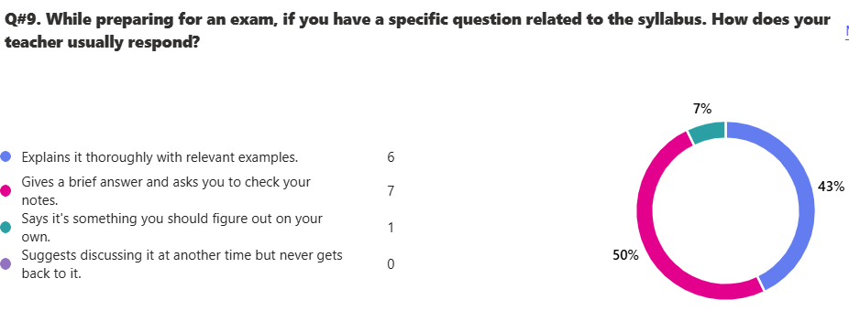

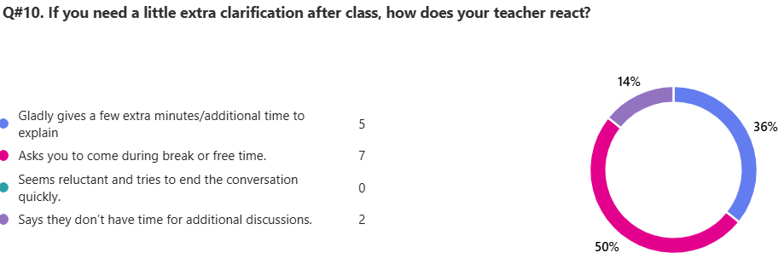

13. Any feedback that you would like to share with Board of Directors.

ID | Responses
1 | Please give longer breaks
2 | bad format of questions since we cant tell what teachers we are asked about in the latter questions
3 | said this last year and im saying this again : just be humble with your students, nothing more
4 | To conduct interclass quizzes that do not relate with the academic results; they are conducted to check your capability.
5 | kindly give us better teacher for physics , kamran rahseed sir doesnot know how to teach
6 | just change SIR GHAUS AS HE DO SO MANY IRRELIVENT QUESTIONS IN CLASS AND HALF POF THE TIME IS WASTE IN THISBH
7 | i just want to say that many teacher always talk rudely. PLEASE change sir ghaus maqsood as he asks many questions and the period is also wasted
8 | SIE GHAUS MAKE MANY DISSCUTION IN CLASS SO PLZ CHANGE THE CS SIR

IG-III Mercury - Boys
Total Reponses: 14
Q#1: Which teachers encourage you the most to ask questions about the topics being studied and are happy to answer them? *You may select as many options as you like.
Name | Responses | Percentage
Mr. Sajjad ur Rehman - Chemistry | 11 | 27%
Mr. Ali Javed - Physics | 9 | 22%
Ms. Anila Rafaqat - Biology | 7 | 17%
Ms. Bushra Abbas - English | 7 | 17%
Ms. Sadia Bashir- Math | 6 | 15%
None of the above | 1 | 2%

Q#2: Which teachers report late for the class? * (You may select as many options as you like.)*
Name | Responses | Percentage
None of the above | 9 | 56%
Ms. Anila Rafaqat - Biology | 3 | 19%
Ms. Bushra Abbas - English | 3 | 19%
Mr. Sajjad ur Rehman - Chemistry | 1 | 6%
Ms. Sadia Bashir- Math | 0 | 0%
Mr. Ali Javed - Physics | 0 | 0%

Q#3: Which teachers conclude their classes before the allotted time? * (You may select as many options as you like.)
Name | Responses | Percentage
None of the above | 12 | 71 %
Ms. Bushra Abbas - English | 2 | 12%
Mr. Sajjad ur Rehman - Chemistry | 1 | 6%
Ms. Anila Rafaqat - Biology | 1 | 6%
Ms. Sadia Bashir- Math | 1 | 6%
Mr. Ali Javed - Physics | 0 | 0%

Q#4: Which teachers indulge in irrelevant discussions. * (You may select as many options as you like.)
Name | Responses | Percentage
None of the above | 10 | 67%
Ms. Anila Rafaqat - Biology | 2 | 13%
Mr. Ali Javed - Physics | 2 | 13%
Ms. Bushra Abbas - English | 1 | 7%
Mr. Sajjad ur Rehman - Chemistry | 0 | 0%
Ms. Sadia Bashir- Math | 0 | 0%

Q#5: Which teachers use cell phones in their classes? * (You may select as many options as you like.)
Name | Responses | Percentage
None of the above | 14 | 100%
Mr. Sajjad ur Rehman - Chemistry | 0 | 0%
Ms. Anila Rafaqat - Biology | 0 | 0%
Ms. Sadia Bashir- Math | 0 | 0%
Mr. Ali Javed - Physics | 0 | 0%
Ms. Bushra Abbas - English | 0 | 0%

Q#6. Which teacher asks you to take paid tuition from him/her in the evening to get an A* or a good grade?
Name | Responses | Percentage
None of the above | 13 | 93%
Ms. Bushra Abbas - English | 1 | 7%
Mr. Sajjad ur Rehman - Chemistry | 0 | 0%
Ms. Anila Rafaqat - Biology | 0 | 0%
Ms. Sadia Bashir- Math | 0 | 0%
Mr. Ali Javed - Physics | 0 | 0%

Q#7. Which subject do you find most challenging?
Name | Responses | Percentage
Mr. Ali Javed - Physics | 5 | 25%
Ms. Bushra Abbas - English | 5 | 25%
Mr. Sajjad ur Rehman - Chemistry | 4 | 20%
Ms. Anila Rafaqat - Biology | 4 | 20%
Ms. Sadia Bashir- Math | 2 | 10%
None of the above | 0 | 0%

Q#8. How would you rate the teacher’s overall performance?
Name | Ranking
Mr. Sajjad ur Rehman - Chemistry | 1
Mr. Ali Javed - Physics | 2
Ms. Sadia Bashir- Math | 3
Ms. Bushra Abbas - English | 4
Ms. Anila Rafaqat - Biology | 5

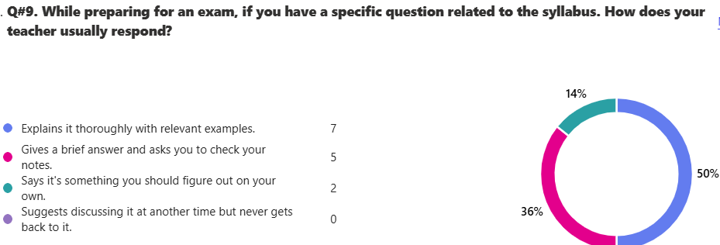

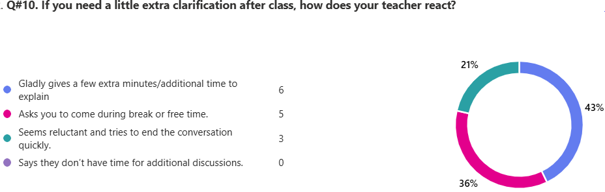

13. Any feedback that you would like to share with Board of Directors.
10 responses

ID | Responses
1 | improve campus conditions
2 | kindly give us a suitable class, with proper air conditioning. we also get the ground only once in the whole week, while other classes get 3 or 4 ground periods, kindly solve this issue.
3 | Nothing, I just joined this school, However, it is a bit crowded and sometimes bullying is seen which is common in boys but still off putting for the victim
4 | I am satisfied with all teachers but although sir ali javed is a great person i do not think he is capable enough to teach at a level that the rest of all teachers do and i am afraid of my physics grade being at risk.
5 | All teachers teach well and good. However, less notes are made in biology class in my opinion . its not a big issue becuase i read book at home so its alright.
6 | It is a gentle and and humble request to my honorable Board of Directors, to please hire someone to keep a strong check on the class's discipline. Many individuals indulge in foul language as well as physical conflicts.
7 | not satisfied with mam sadia it seems that i have wasted 3 years which could be used to ace math subject and exams had to struggle in online and face to face academies
8 | Thankfully all is going well but there is one problem that we dont have games not even for a single in a week which is quite fruastating .kindly please change our time table
9 | Mam Saadia does not let students ask her questions and only raises her voice instead of actually explaining. Our class IG 3 Mercury barely has a single break where we have games. Our class wall are filthy and not clean.
10 | in my opinion, i believe that studying with mam aneela rifaqat is being a bit challenging. I agree that teachers must console students but indulging in too much irrelevant discussions is not appropriate at all. Due to this students become very shy and another reason for this is that she always drops students confidence as she always gets mad on their performnce which mostly shatters their confidence.

